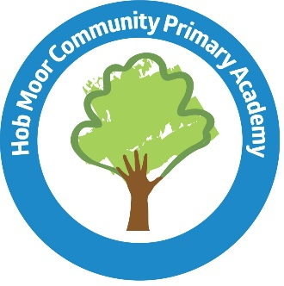

Free School Meal Application
(Consent for school to apply on my behalf)

I give permission for Hob Moor Primary School to apply on my behalf to establish whether my child is entitled to free school meals.

I agree that you will use the information provided to process my claim for free school meals and will contact other sources as allowed by law to verify my initial, and ongoing, entitlement.
I agree that the information may be used to ensure accuracy of records across the local authority and the check against fraud.
I agree that you can inform the school(s) attended by my child of their initial and ongoing entitlement to free school meals.

Child’s full name: ………………………………………………………………………………………………………………………………

Child’s date of birth: ………………………………………………………………………………………………………………………….

Parent/Carer’s full name …………………………………………………………………………………………………………………..

Parent/Carer’s date of birth: ………………………………………………………………………………………………………………

Parent/Carer’s National Insurance Number: ……………………………………………………………………… OR
National Asylum Support Service reference number: ………………………………………………………………………..
Home Address: …………………………………………………………………………………………………………………………………..
……………………………………………………………………………………………………………………………………………………………
……………………………………………………………………………………………… Postcode: …………………………………………..

Signed: ……………………………………………………………… (Parent/Carer) ………………………………….…. (Date)

